**Assignment 4:**

**Write a program which accepts the values from console, use method overloading and overriding concept to display the results by calculating largest values from the variables**

**Source Code:**

**import java.io.Console;**

**class Parent {**

**public void message() {**

**System.out.println("Method of Parent");**

**}**

**}**

**class Child extends Parent {**

**public void message() {**

**System.out.println("Method overided and called via Child");**

**}**

**public int maxx(int a, int b, int c) {**

**return (a > b) ? ((a > c) ? a : c) : ((b > c) ? b : c);**

**}**

**}**

**class OverloadAndRide {**

**public static void main(String[] args) {**

**Child obj1 = new Child();**

**// Reading values from console**

**Console console = System.console();**

**int a = Integer.parseInt(console.readLine("Enter first number: "));**

**int b = Integer.parseInt(console.readLine("Enter second number: "));**

**int c = Integer.parseInt(console.readLine("Enter third number: "));**

**obj1.message();**

**System.out.println("Max of 3 numbers is = " + obj1.maxx(a, b, c));**

**}**

**}**

**Output:**

**Enter** first number: 6

**Enter** second number: 5

**Enter** third number: 9

**Method** overided **and** called **via** Child

**Max** of 3 **numbers** is = 9

**Write a simple java program that reads and writes the inputs from the file.**

**Source Code:**

**import java.util.Scanner;**

**import java.io.*;**

**public class Files {**

**public static void main(String[] args) {**

**Scanner infile;**

**PrintWriter outFile;**

**try {**

**infile = new Scanner(new File("input.txt"));**

**outFile = new PrintWriter("output.txt");**

**while (infile.hasNext()) {**

**int num = infile.nextInt();**

**outFile.println(num);**

**}**

**infile.close();**

**outFile.close();**

**} catch (Exception e) {**

**System.out.println("File not found");**

**System.out.println(e.getMessage());**

**}**

**}**

**}**

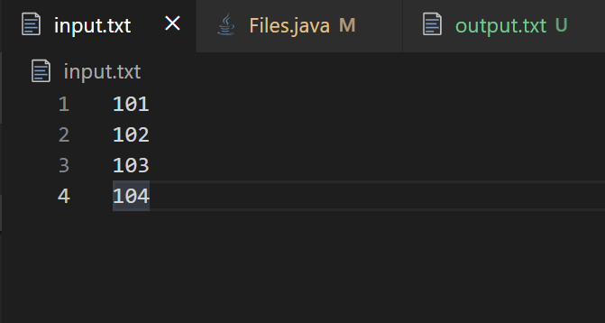**Output:**

*input.txt*

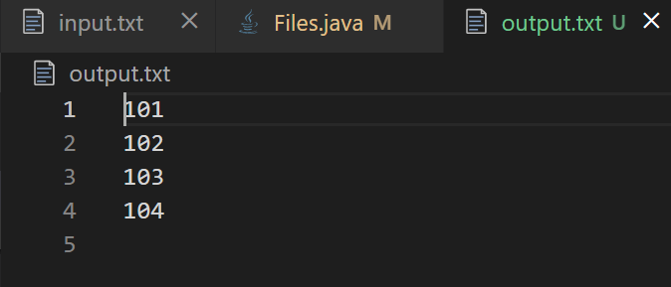

*output.txt*